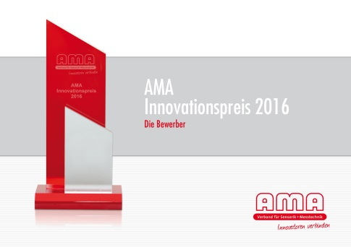

Broschüre:

http://ama-sensorik.de/fileadmin/Innovationspreis/AMA_Booklet_IP_16_A5_w_neu.pdf

Press Release

AMA Innovation Award 2016:
Magnetic Flow Cytometry and Nerves of Glass Sway Jury

Nuremberg/Berlin, 10 May 2016—The AMA Association for Sensors and Measurement (AMA) will present the winners of the AMA Innovation Award 2016 at the SENSOR+TEST trade fair in Nuremberg on 10 May. This year, the 10,000-euro prize will go in equal parts to the developers of two submissions, which the jury deems to have an outstanding degree of innovation as well as great market relevance: the Magnetic Flow Cytometry project by the developer team of Siemens Healthcare, Sensitec, Sencio, and M2 Automation swayed the jury, as did Nerves of Glass – Fiber-Optical 3D-Positioning of Cardiac Catheters by the developer team from Photonik Inkubator Niedersachsen and the Fraunhofer Heinrich-Hertz Institute.

Magnetic Flow Cytometry
The development of magnetic flow cytometry enables detection of target cell functions by marking blood cells with magnetic nanoparticles. The workflow uses a blood-filled cartridge without the need for sample preparation. The concentration measurement counts the magnetically marked cells on site, near the patient, within minutes. The high detection precision allows decisions regarding therapy for unstable cellular biomarkers, which was not feasible with competing processes, as routine applications would involve inordinate investments and specialized knowledge. The jury and AMA Association extend their best wishes to the developer team: Dr. Oliver Hayden, Lukas Richter, Michael Helou, Mathias Reisbeck (Siemens Healthcare, Erlangen), Ronald Lehndorff (Sensitec), Ignaz van Domelein (Sencio), Mario Nitzsche (M2 Automation). (www.healthcare.siemens.com)
Nerves of Glass
The other award-winning innovation is Nerves of Glass. This novel, fiber-optical 3D positioning of cardiac catheters is a precision navigation and tracking system of great significance in minimally invasive radiology and surgery. Three-dimensional shape and motion detection by means of fiber optical sensors enables repositioning of cardiac catheters with an exactitude of less than one millimeter. This is a decisive contribution to the improvement of successful results and the reduction of the required operating duration for the medical therapy involved. The jury and AMA Association congratulate the developer team: Professor Dr. Wolfgang Schade, Dr. Martin Angelmahr (Fraunhofer HHI, Goslar), Christian Waltermann, Anna Lena Baumann (Photonik Inkubator/ Fraunhofer HHI), Philip Gühlke (Photonik Inkubator, Göttingen).
(www.photonik-inkubator.de)

“Young Enterprise” Special Award for 4D-Microscope Camera
The special award goes to the developer team headed by Dr. Rachel Wang Ruiqi (d'Optron Pte Ltd., Nanyang Technological University) for the development of the “d’Bioimager,” a real 4D-microscope camera (3D-imaging in real-time) dedicated to biomedical applications. The “young Enterprise” from Singapore received a free trade-fair presence at the SENSOR+TEST 2016.
(www.doptron.com)

Biomedical Technology as Overall Winner
“This year, 41 innovate research and development teams submitted first-rate development projects competing for the AMA Innovation Award. Both winning projects, Nerves of Glass and Magnetic Flow Cytometry, with their scientifically outstanding solutions and evident practical utility were neck to neck with the other nominees, but won by a nose,” said jury chair Professor Andreas Schütze from the Saarland University, commenting on this year’s selection. “Over though, it was biomedical technology that won the race. Surprisingly, all five nominated teams had developed innovative solutions for medical applications, albeit based on completely different sensor and measurement principles,” added Schütze.

Brochure with all Submissions for 2016
The AMA Innovation Award, endowed annually by the AMA Association, has been considered for years as one of the most renown awards in sensor and measuring technology. All submitted projects and their innovations are briefly described in the brochure “AMA Innovation Award 2016 – the Competitors,” which can be downloaded free of charge from
www.ama-sensorik.de/en/science/ama-innovation-award/ama-innovation-award-2016/.

Submissions for the Innovation Award 2017
Forms for submissions to the AMA Innovation Award 2017 will be available online as of the end of October 2016. Projects can be submitted by individuals or development teams from enterprises and institutes. For more information, see
www.ama-sensorik.de/en/

Characters (incl. spaces): 4,176

The AMA Association for Sensor Technology (AMA) – linking innovators. The AMA is the network and representative of the interests of the key industry in technical innovations. The AMA is the first contact for sensor and measuring technology and provides a comprehensive overview of products and services in its industry directory. The AMA cultivates an innovation dialog among all parties in the process at the leading trade fair SENSOR+TEST, at community stands of important fairs worldwide, and at the science conferences SENSOR and IRS². The AMA offers technology seminars concentrating on sensor, measuring, and microsystem technology.

Press contact:
AMA Verband für Sensorik und Messtechnik e.V.
Ms. Pascale Taube
Press and PR Officer
Sophie-Charlotten-Str. 15 / 14059 Berlin / Germany
Tel. +49 30 22190362-20 / Fax +49 30 22190362-40
taube@ama-sensorik.de / www.ama-sensorik.de

